**Isaac -150182  
Search for Unsecured Vulnerable MongoDB Databases**

Some databases by design do not use authentication by default. Two such databases are

MongoDB and Elasticsearch

In the search bar, if we type, “MongoDB Server Information” port:27017 -authentication

will retrieve MongoDB servers from Shodan, showing us how many MongoDB databases are

running on port number 27017.

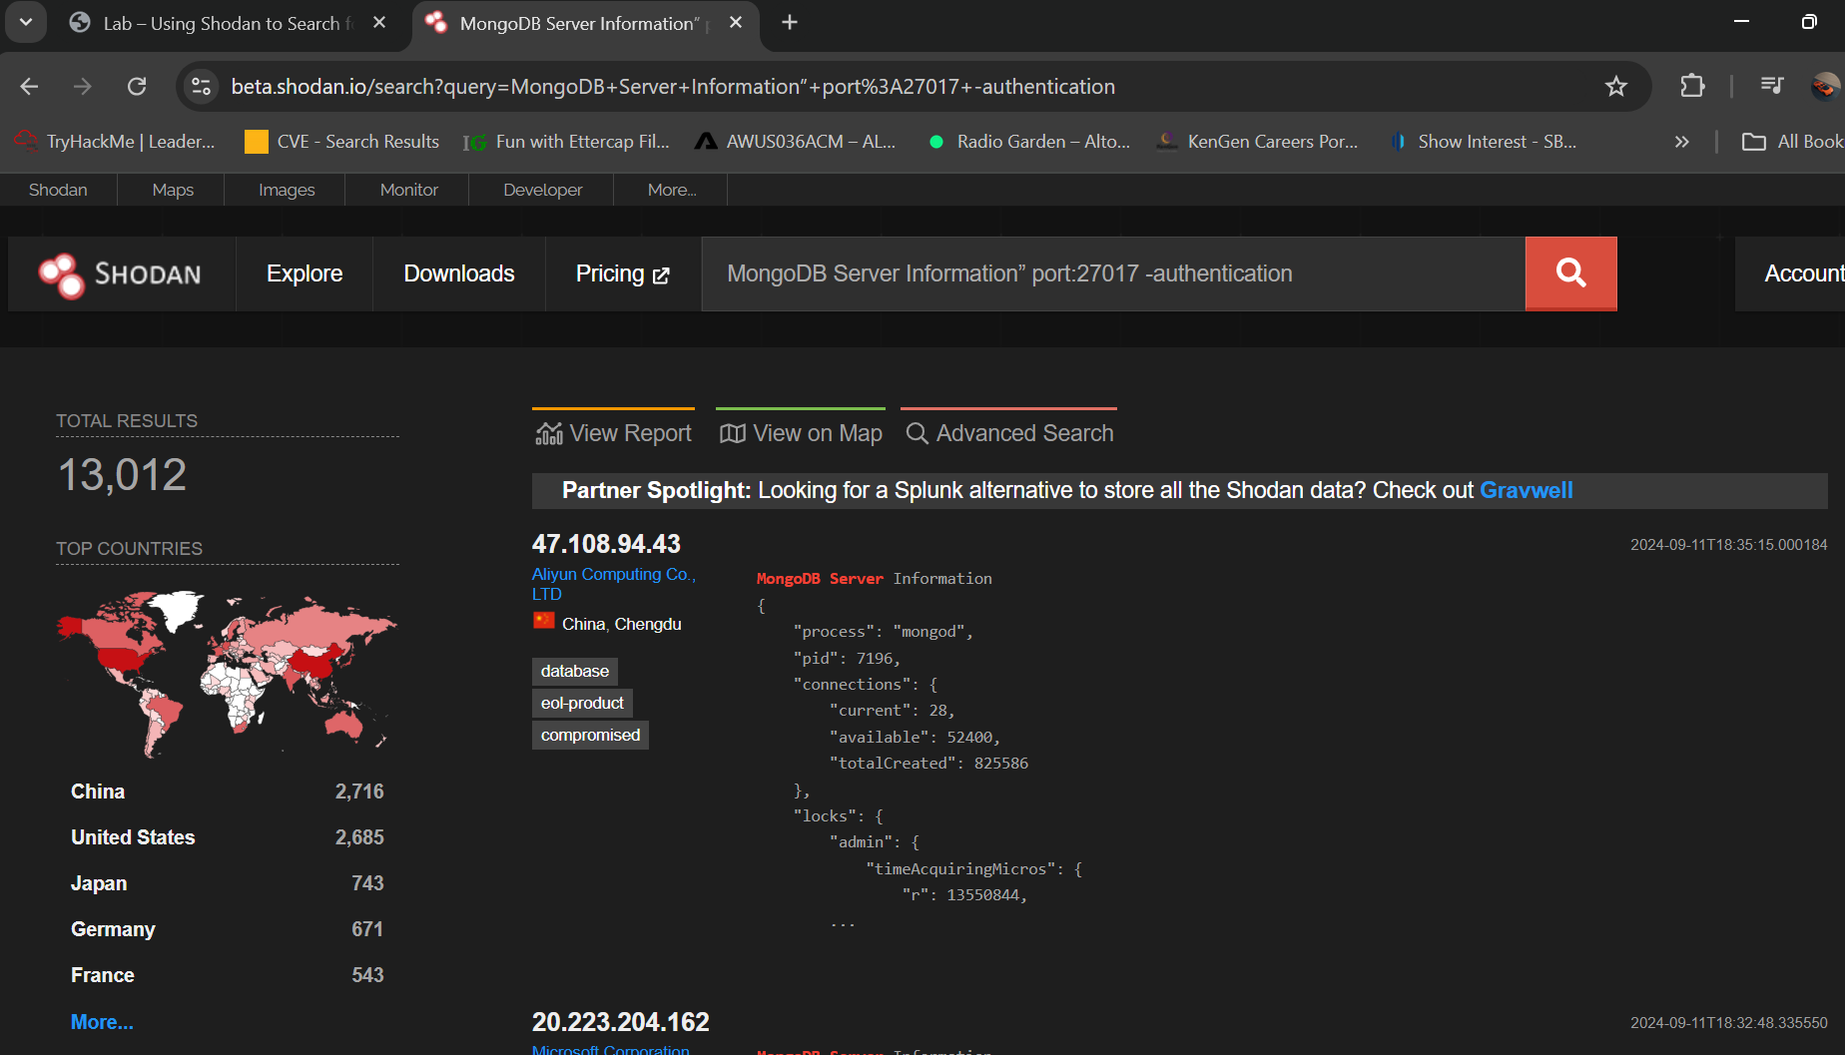

To gain access to the unsecured data, we click on the IP address

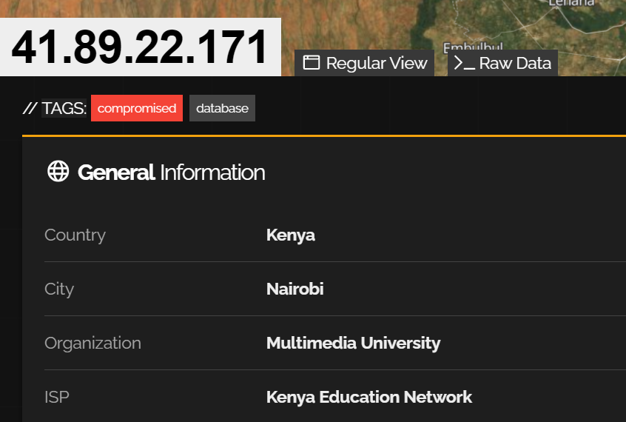

On the next page, under ports, find the port the MongoDB is using port 27017.

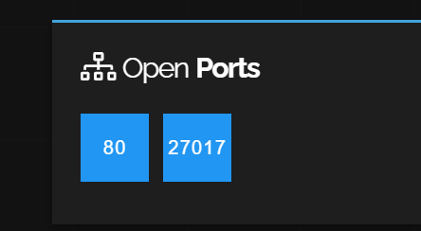

Clicking on the port number will take you directly into the unsecured database without being

prompted for any user name or password

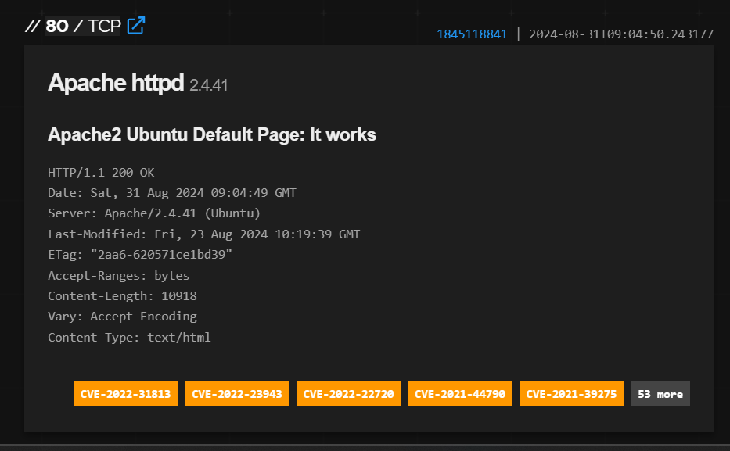

Search for Unsecured Vulnerable Elastic Databases

For this search query, we will be using the following search filter, product:elastic port:9200

You’ll notice in your results that many of the Elastic databases have been compromised and left

with a banner message stating:

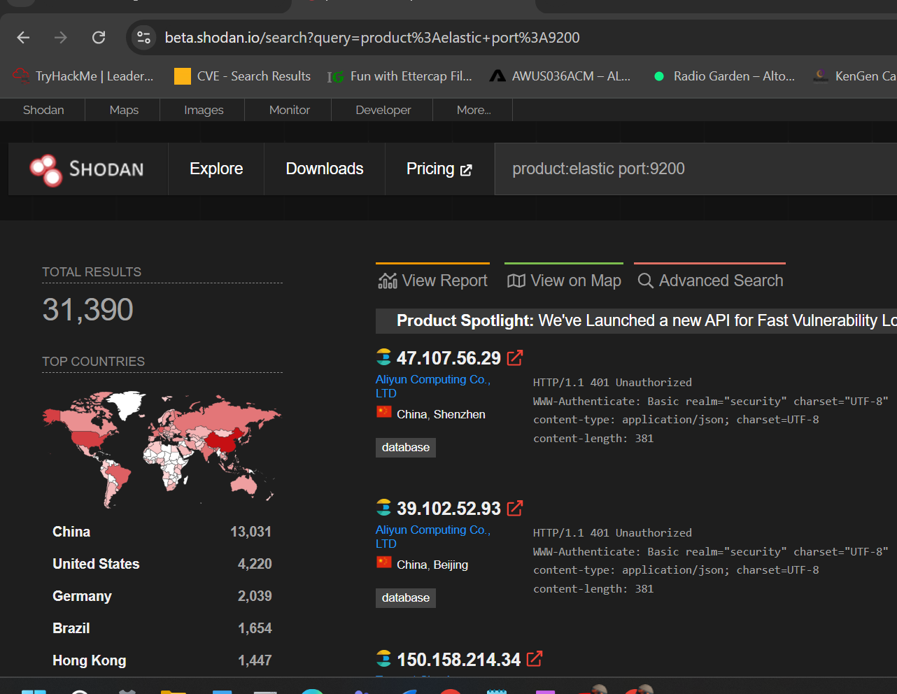

On the next page, if you click on the port number 9200.

